The Descriptive Prompt Method: 3 Ways To Generate What You Want, Every Time— Forever With AI
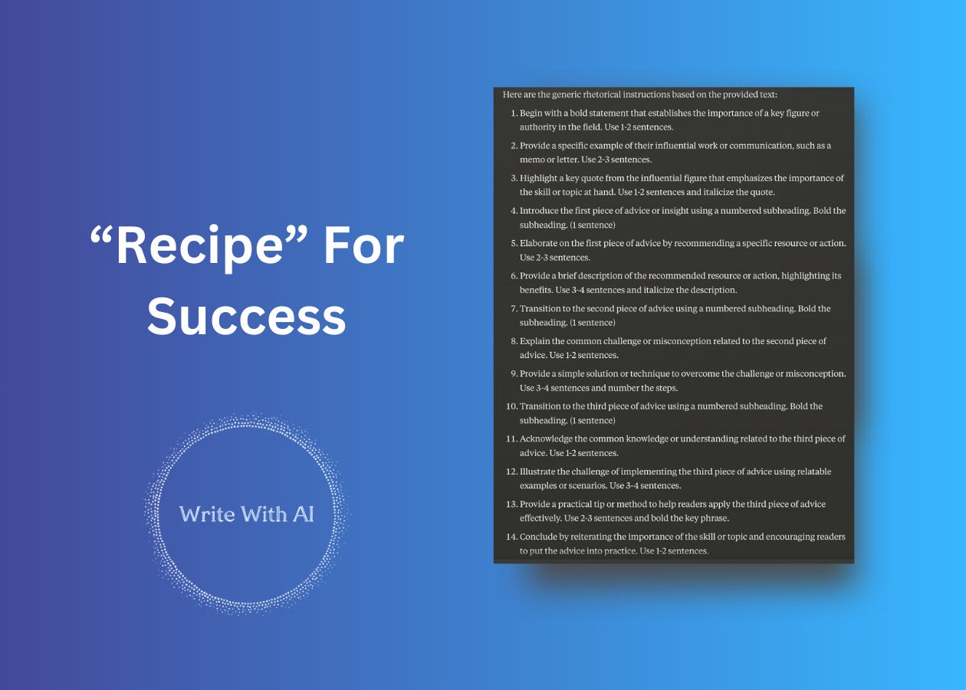

Hey there, Digital Writers!
Newsflash:
AI can’t read your mind.
It’s incredibly powerful—but it needs clear direction. The more specific you are about your desired output, the better AI can deliver (every time you ask).
And one way you can do this is by using “descriptive” prompts.

Descriptive Prompting
Descriptive prompts are exactly that—descriptive.
They provide detailed context and step-by-step instructions to the AI to guide it in generating the desired output. You can use this style of prompt to generate articles, outlines, ideas, and even images. The more specific and descriptive the prompt, the more likely the AI will produce relevant and useful results.
Imagine you were going to teach an alien how to make coffee, what are all the things you would need to “describe” to your new martian friend so that they could make a cup of coffee?
First, they need to understand:
- Why people drink coffee.
- The difference between whole coffee beans and ground coffee.
- What a coffee maker is, along with filters, water, and the brewing process.
They need a bunch of context, right?
Then once you have given them the context, you would need to describe all the steps to actually brew the coffee.
- Open the coffee maker and locate where the filter should be placed.
- Insert a filter—it should fit snugly, like a tiny cup.
- Add one scoop of coffee grounds per desired cup of coffee into the filter.
- Pour water into the machine’s reservoir—one cup of water per scoop of coffee used.
- Close the coffee maker and press the start button.
- Wait as the machine makes gurgling noises—this is normal, it's just doing its job.
- Once the machine stops making noise and the coffee ceases to drip, your coffee is ready.
- Pour the hot coffee carefully into a mug.
- Optionally, add milk or sugar to enhance the flavor.
It’s a lot once you start to break it down.
But, when you give clear, detailed instructions, it’s much easier for someone unfamiliar (like a visitor from outer space) to understand what to do. If your instructions are vague, they'll still try to follow them, but they might not do it right. For instance, if you don't specify how to turn on the coffee maker by pressing the button, they might just pour water on the coffee grounds instead. You'll still get coffee, but it won't be prepared the way you intended.
The same is true with descriptive prompts.
So, to get the best out of AI, just spell out what you need it to do—and give it your recipe for success.

This sounds like it takes a lot of time?
Why not write the content directly instead of creating a detailed prompt?
It's a good question.
But here's the thing:
Using AI can save you a lot of time, especially if you regularly need similar types of content. By teaching the AI exactly how you want your content structured—whether it's a sentence, a paragraph, or an entire article—you set yourself up to get consistent results quickly, no matter the topic.
This doesn’t mean your defer all the thinking to AI.
Your input and context are still crucial. However, by giving precise instructions, you streamline the content creation process. This is especially useful for producing how-to guides, listicles, or explanatory articles efficiently.

How To Write Descriptive Prompts
There are 3 ways you can go about doing this:

1. Reverse Engineer Your Own Writing
One of the best ways to create descriptive prompts is to reverse engineer your own writing process. Take content you've already written and break it down into steps. Explain the purpose and key elements of each part.
For example, let's say you want to teach the AI to write introductions like you do. Study your typical intro paragraph and note each sentence's role:
- Sentence 1: Bold opener that provokes curiosity
- Sentence 2: Introduces the problem the article addresses
- Sentence 3: Hints at a solution
- Sentence 4: Thesis statement summarizing key points
Document this structure in your prompt.
Focus on the intent behind each piece rather than the grammatical specifics. The goal is to teach the AI your writing patterns so it can replicate them. This takes some introspection and analysis of your work. But by making your implicit writing knowledge explicit, you enable the AI to produce intros that match your preferred style and flow.
You can apply this reverse-engineering process to any aspect of your writing—intros, conclusions, paragraphs, transitions, stories, examples, etc.
The more thoroughly you break down what makes your content effective, the better you can teach the AI to do the same.

2. Ask The AI To Break Down The Steps
Another option is to prompt the AI to explain the process for a writing task, outlining each step like it's teaching a 5-year-old.
Here's a prompt you can adapt for almost any type of content:

Describe step-by-step how to write a {CONTENT TYPE} for someone who has no prior knowledge.

Assume I am a complete novice, and you are the expert.

Teach me as if I am a young child.

Simplify your explanations and breaking down the instructions to first principles.

Provide a clear, detailed, line-by-line guide using chain of thought.

Instructions should read like a rhetorical structure for the artifact.

Section by section. Sentence by sentence, including the number of sentences to write.

Return the instructions like a script that I could execute as an AI prompt for any topic I want.

~

A good result looks something includes details like this:

Begin with a bold statement that promises to transform the reader's approach to the topic at hand. Use 1-2 sentences.

Describe the common challenge or frustration that most people face when attempting the task. Use 2-3 sentences.

Explain why this conventional approach is ineffective and leads to suboptimal results. Use 1-2 sentences.

Use a subheading to introduce a contrasting perspective that challenges the status quo. Bold the subheading.

Reveal the key insight or secret that separates the most successful individuals from the rest. Use 1-2 sentences.

Provide a vivid analogy or metaphor that illustrates the limitations of the conventional approach. Use 1-2 sentences.

Introduce the alternative approach used by the most effective practitioners. Use 1-2 sentences.

Provide a high-level overview of how this superior approach works. Use 1 sentence.

Signal that you're about to dive into the details of this approach. Use 1 sentence.
...
For example:
"Describe step-by-step how to write a persuasive essay. I have no context. You are the expert..."
The AI will respond with a detailed, linear process you can use as the foundation for your descriptive prompt, adding additional instructions and guardrails as needed.

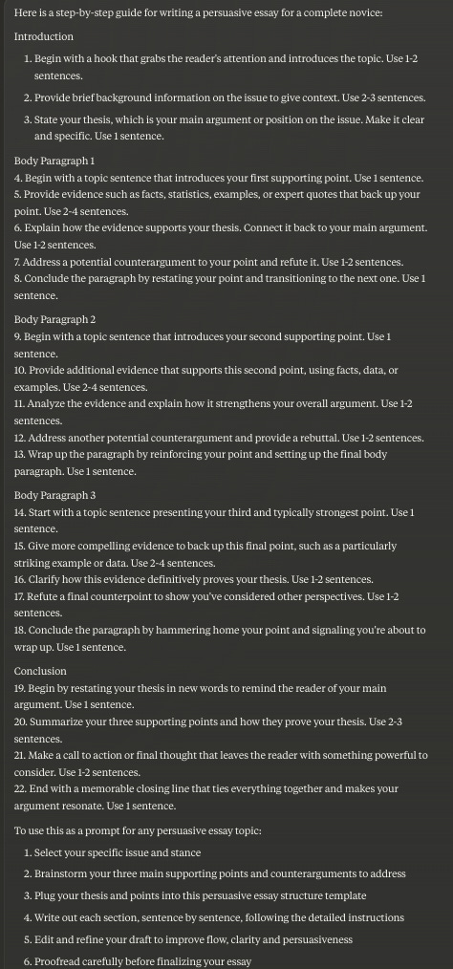

This leverages the AI's knowledge to make the prompt creation process easier.
Instead of having to document the writing process from scratch yourself, you start with the AI's breakdown and then customize it.

3. Reverse Engineer Proven Writing
The third way to create descriptive prompts is to feed the AI examples of existing content and have it identify the core elements and structure.
Find a piece of writing that achieves the style and impact you want to emulate. Ask the AI to analyze it and describe the key components. Then turn those components into a step-by-step prompt template.
For instance, if you admire how a particular author tells captivating stories, you could feed the AI one of their articles and ask it to dissect their storytelling techniques. It might come back with:
- Opens with a punchy first sentence that introduces a character
- Describes an obstacle or challenge the character faces, using vivid sensory details
- Narrates how the character resolves the challenge and what they learn as a result
- Closes by linking the story's message back to the article's overall point
You can then reuse this story structure in prompts to generate your own engaging anecdotes and examples. The AI helps identify what makes the original compelling, giving you a tried-and-true template to build on.
Here’s the prompt:
# TASK

I am going to give you a TEXT.

Your job is to transform the TEXT into a completely abstracted and generic rhetorical script.

Please create a set of generic rhetorical instructions that can be applied to any text on any subject. The instructions should be abstract, avoiding any mention of specific content, examples, or details from the text I provide. Each rhetorical statement should be framed as a broad directive that guides the writing process universally, without referring to any particular topic, issue, or example.

Be detailed in your approach. Specify the number of sentences or number of words in your instruction.

# EXAMPLE RHETORICAL STATEMENTS

Begin with a bold statement that promises to transform the reader's approach to the topic at hand. Use 1-2 sentences.

Describe the common challenge or frustration that most people face when attempting the task. Use 2-3 sentences.

Explain why this conventional approach is ineffective and leads to suboptimal results. Use 1-2 sentences.

Use a subheading to introduce a contrasting perspective that challenges the status quo. Bold the subheading.

Highlight a common problem behavior using relatable examples. Use 7 sentences.

# Rules

Your Rhetorical Statements MUST BE GENERIC.

You are creating Rhetorical Statements for the TEXT.

You MUST include statements that cover all sections and paragraphs in the provided text.

Do you understand?

Let me know when you are ready for the TEXT.
Let's try it out with the first few paragraphs of this listicle “10 Writing Tips From the World's Best Marketer.”
Boom! In seconds, you have a script you can use to write a brand new listicle.

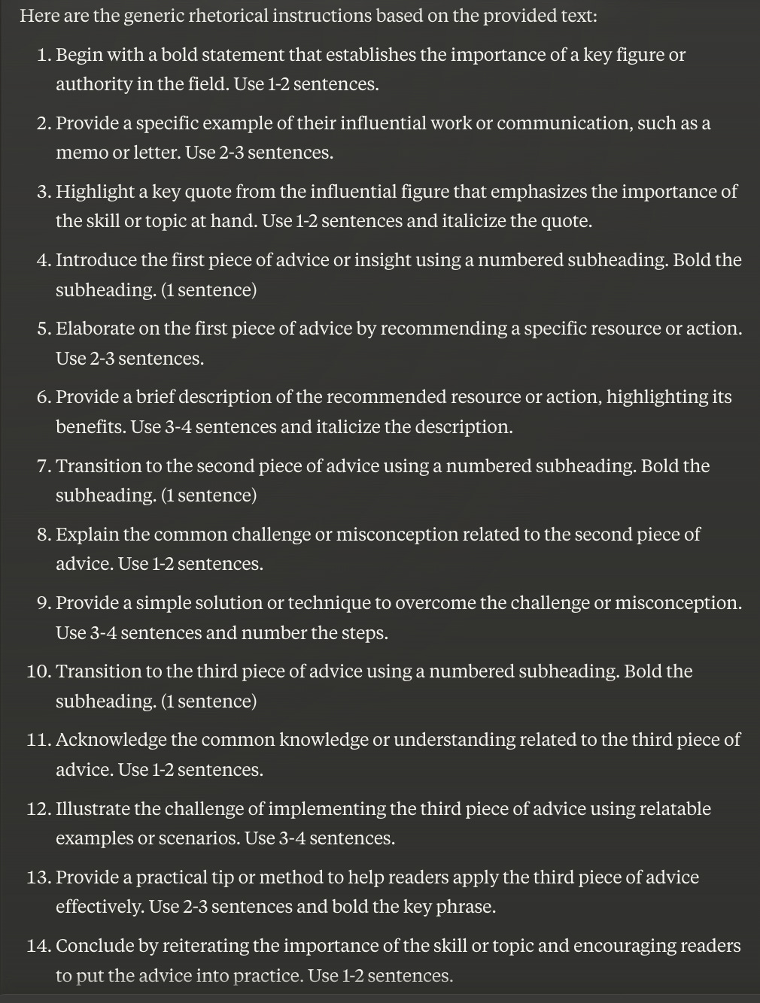

Now, once you have a script you can use it to write something new for your niche / topic.
Which is what we are going to do next.

Write A Fresh Piece Of Content Using Your Descriptive Prompt Recipe
To create new content using your descriptive prompt “recipe,” you need to tell the AI what your topic is. Do this by filling in the prompt template below with your specific topic, intended audience, and any context. Think of it as following a recipe to ensure you include all the necessary ingredients for a great piece of writing.
Here’s the prompt template:
# INPUT

Topic = {Your topic}

Audience = {Your target audience}

Outcome = {The outcome you are promising}

Context = {Any additional details.}

# Writing Style

Plain and simple.

# TASK

Please create a new {NUMBER} word text using the INPUT and TEMPLATE I've provided.

# TEMPLATE =

{Insert A Descriptive Prompt}

# CONSTRAINTS

Avoid metaphors.
Avoid antithesis phrases.
Avoid purple prose AT ALL COSTS
Avoid words like "imagine, streamline, realm, game-changer, unlock, discover, skyrocket, abyss, you're not alone, in a world where, revolutionize, etc"

# Now, take a deep breath, relax, and try your hardest.
Let’s use the recipe we created in Step 3 and add the below context into the prompt.
Topic = 3 Yoga Poses To Free Your Tight Hips
Audience = College football coaches who want to keep their players injury free off season
Outcome = Players are flexible, loose, and ready to hit the field
Voila!

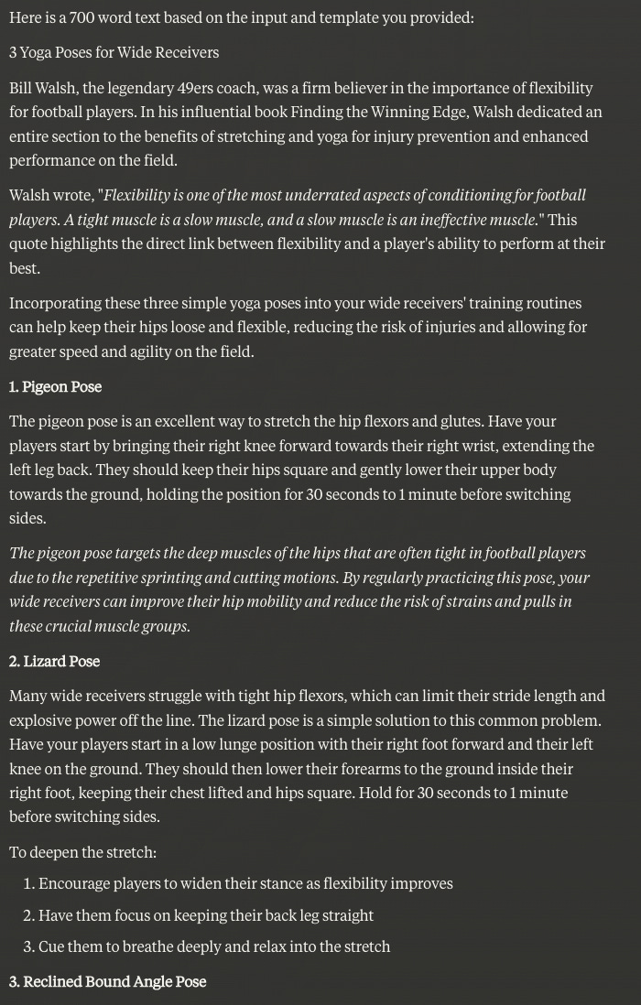

Edit, fact check, and tune-up the formatting.
You’re good to go.
Remember, investing time upfront in thorough prompt creation, you can generate consistent, high-quality, on-target content quickly and easily—on repeat. Take some time to practice deconstructing your own writing, the writing of others, or having AI break down a process. Use those components to start building a library of descriptive prompt templates.

